Trends in attitudes towards doing business with and marrying other ethnicities in Georgia and Armenia

[Caucasus Barometer data](https://caucasusbarometer.org/en/cb-ge/codebook/) has consistently suggested that Georgians and Armenians are more tolerant of doing businesses with other ethnicities, while inter-ethnic marriages are frowned upon. Data from the most recent wave shows that Georgians have become more tolerant of inter-ethnic marriages, while becoming less approving of doing business with foreigners. In contrast, Armenians became less tolerant of both types of relations, with the exception of business partnership with Georgians.

Caucasus Barometer data from 2019 shows that people both in Georgia and Armenia are more tolerant towards having businesses relations with other ethnic and religious groups than approving of women of their natinoality marrying others. A majority approve of all ethnicities asked about on the survey as business partners, except for Turks and Azerbaijanis in Armenia. For Georgians business partnerships with Georgians, Ukrainians, Russians, Italians, Americans, Azerbaijanis, Armenians, Jews and Turks are more accaptable than with Kurds, Indians, Arabs, and Iranians. Armenians follow a similar pattern. However, the rates of approval of doing business with of Azerbaijanis, Turks, Ukraininans, and Jewish people is much lower in regards to business relations.

Attitudes towards doing business with foreigners are becoming more negative in Georgia and Armenia. The biggest decreases in Georgia are towards doing business with Kurds and Turks, which have decreased by 15 and 14 percentage points, respectively. There were 12 percentage point decreases in approval of doing business with Jews, Americans, and Armenians and of 10 percentage points for Italians. In Armenia, the approval rate of business partnerships with Turks, Azerbaijanis, Ukrainians and Jewish people has dropped, by 16, 11, 9, and 8 percentage points respectively. The rest remained relatively similar.

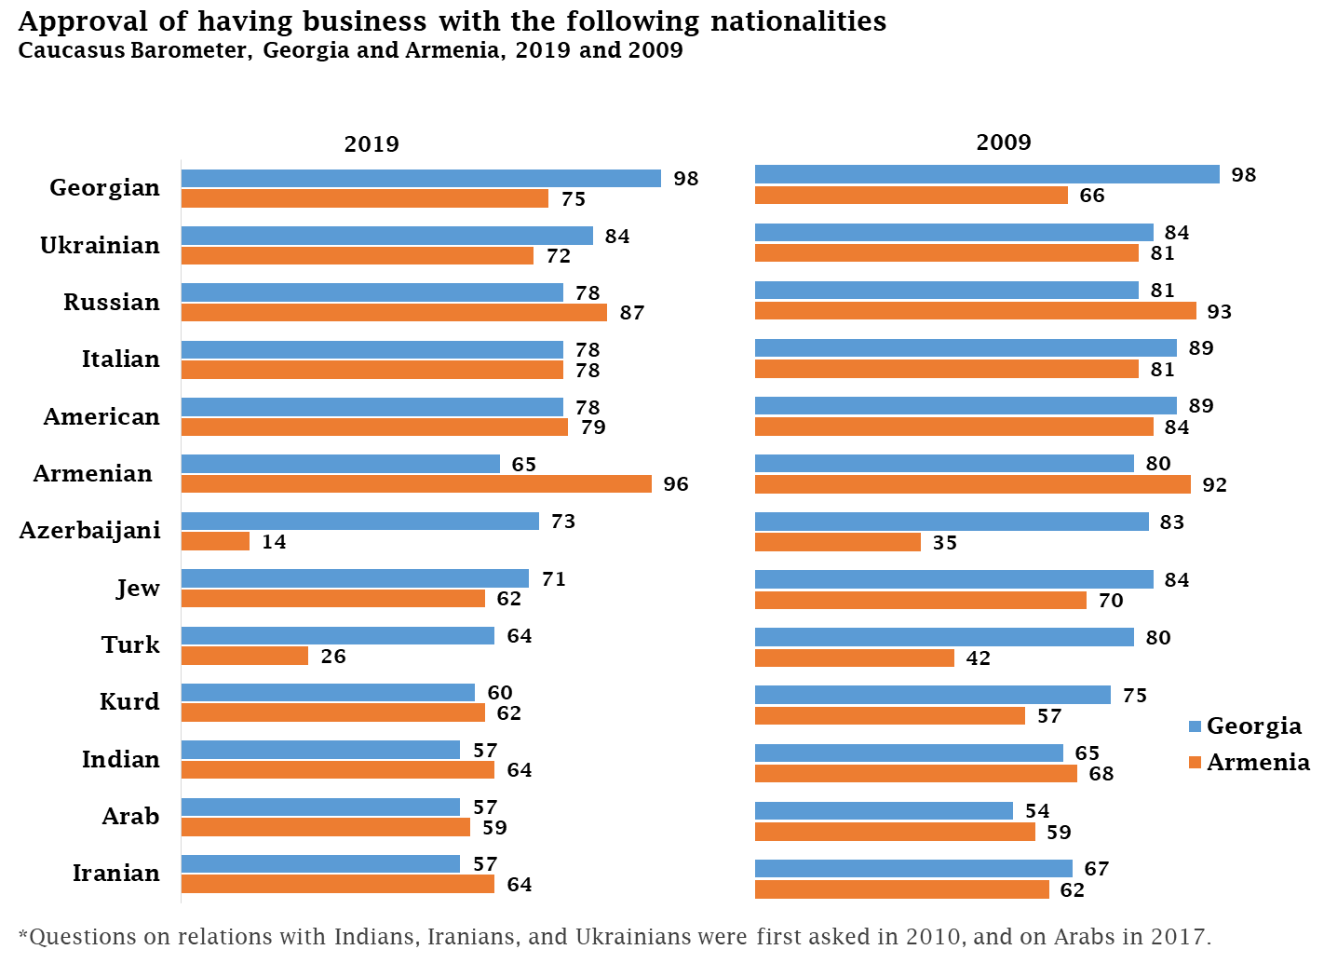

The marriage approval data follows a similar pattern in terms of favored ethnicities as described above, but with much lower levels of approval. However, the trends are different in Georgia and Armenia. The data from 2019 suggest that more people look favorably at inter-ethnic marriages in Georgia compared with 2009. The biggest increase is towards women marrying Azerbaijanis, which has increased by 11 percentage points. It is followed by Turks with a 10 percentage point increase and Kurds (7 percentage points). In contrast, Armenians became less approving of Armenian women marrying men of other ethnicities. The biggest drop is toward women marrying Jews, which decreased by 11 percentage points and Russians, which decreased by 10 percentage points. The trend is similar regarding all nationalities but the difference is relatively small.

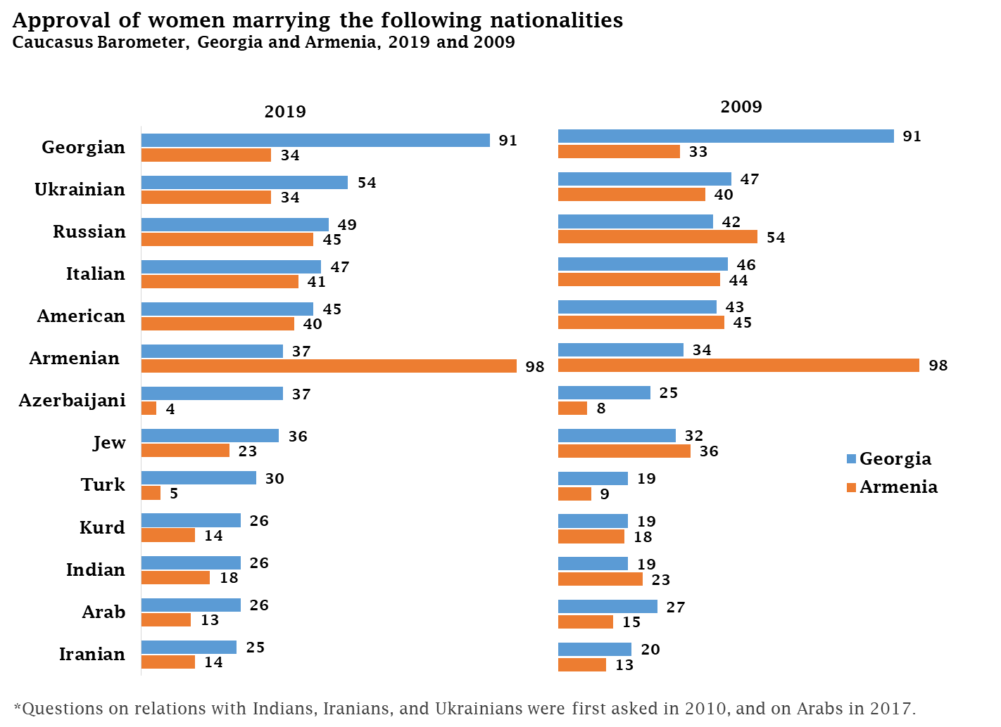

Most Georgians and Armenians approve of doing business with all nationalities asked about in CB, while continuing to disapprove of women marrying foreigners. However, in Georgia there appears to be a more positive trend in approval of marriages with foreigners, while support for business partnerships has declined, albeit slightly. In contrast Armenians are becoming less tolerant towards both having business partnerships with foreigners and women marrying other nationalities.